EE 111L lab 4 report

Xilai Zhang

UID:804796478

1.1 objective

Build circuit that produce 0th-order transfer functions.

1.2. Theory

Part (a) can be produced with a voltage divider of resistors. If two resistors have the same value, the voltage across each resistor will be 0.5 of the output. Part (b) and (c) are constructed by using opamp. As we have seen in lab2, the output of non-inverting amplifier is (1+R2/R1)\*input, and the output of inverting amplifier is (-R2/R1)\*input. Thus if we choose R2=2kOhms and R1=1kOhms for part (b), we would get a transfer function of 3 for part(b) and a transfer function of -2 for part(c).

1.3 Procedure

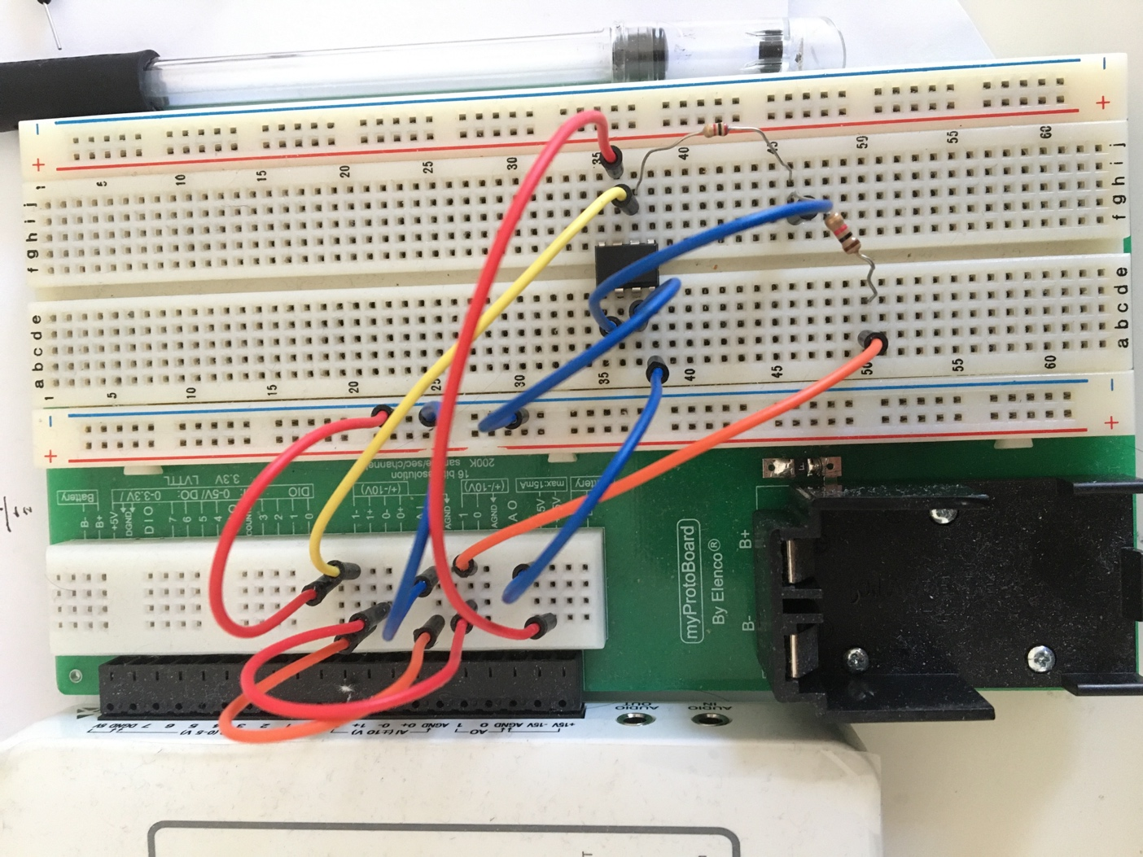

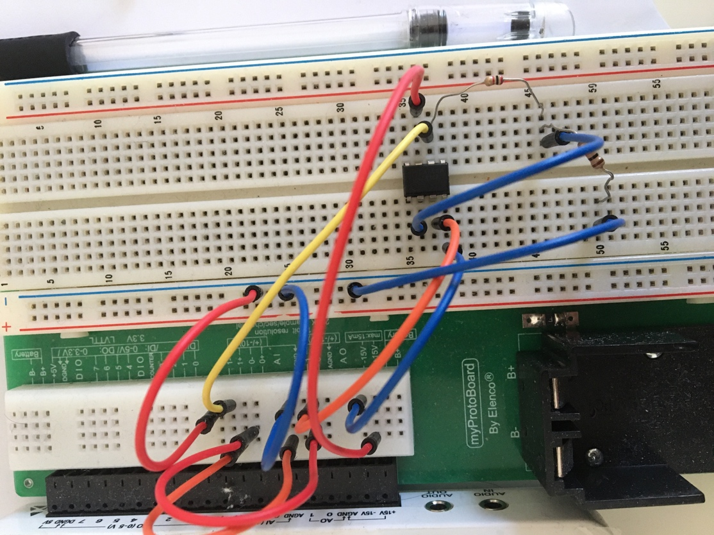

We connect the opamp and resistors as shown in the above pictures to achieve desired transfer functions. The resistor values are 2kOhms and 1kOhms.

1.4 Data and data analysis

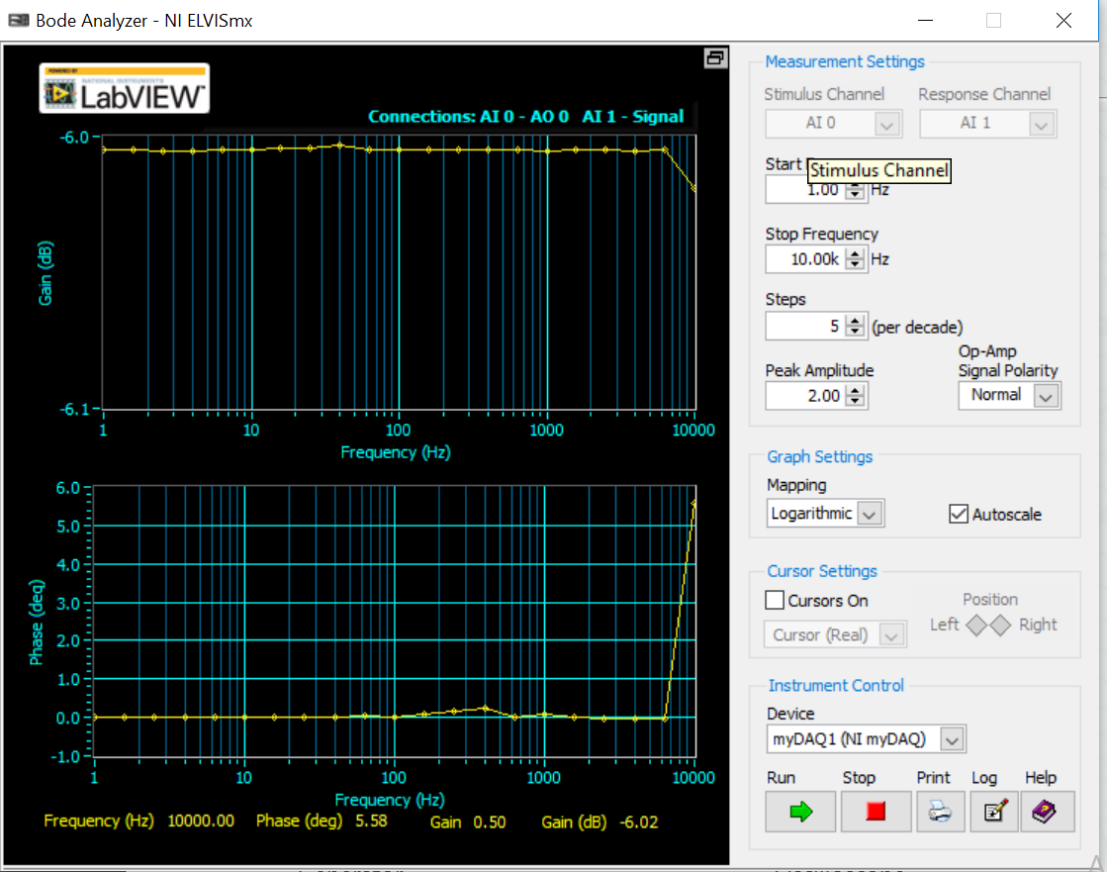

The bode plot when transfer function is 0.5. Since 20log(0.5)= -6.02, we can observe that the bode plot is a straight line with a magnitude close to -6.02.

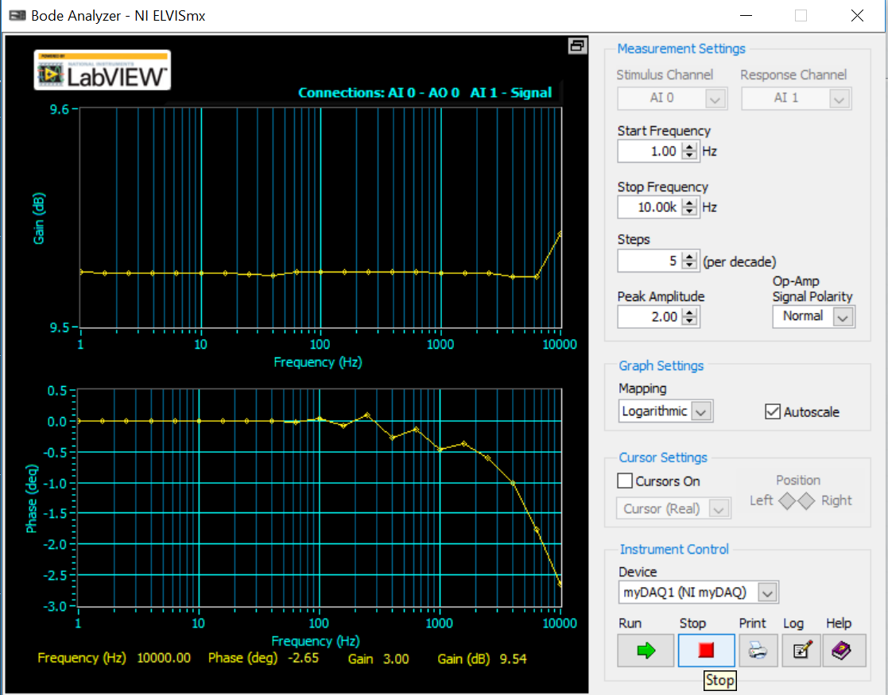

The bode plot when transfer function is 3. Since 20 log(3) is 9.54243, we can observe that the bode plot is a straight line close to the value of 9.5. The magnitude is the same as frequency increases.

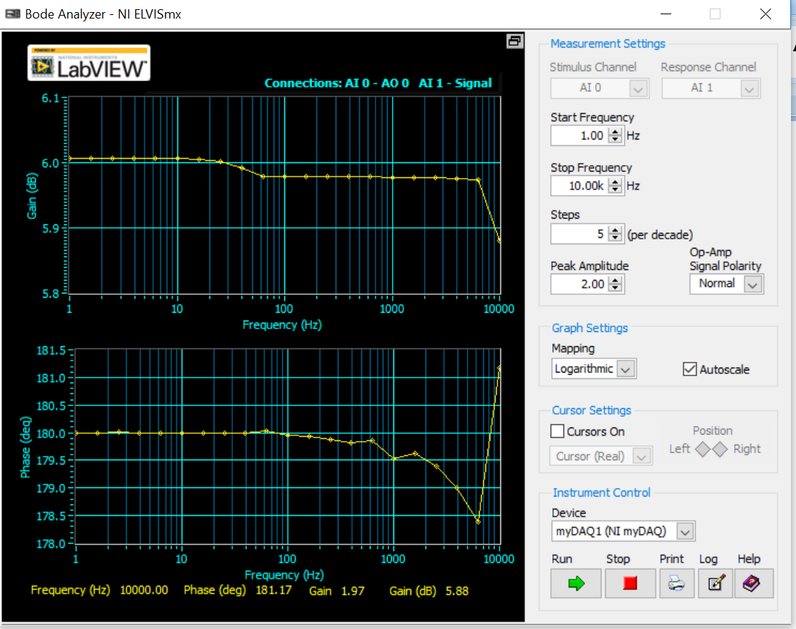

The bode plot when transfer function is -2. Since 20 log (-2)= 6.02 + 27.2 j, we can observe from the bode plot that the magnitude is a straight line close to the value 6.02.

1.5 error analysis

There are minimal fluctuations when frequency is very large. These might be caused by the error from the high frequency stimulus produced by myDaq.

1.6 Discussion

a. There are no poles and no zeros since the transfer functions are constants.

b. The gain factors are the same as the transfer functions, i.e. 0.5, 3, and -2 respectively.

1.7 conclusion

We produced 0th-order transfer functions by using only resistors and opamp, and verified the transfer functions using bode plots.

2.1 objective

Construct first order circuits that have desired transfer functions.

2.2 Theory

Using laplace transform, we know that the voltage across resistor in LR circuit is R/(LS+R) = 1/(1+S/ (R/L)). To produce a pole at -1\*10^3, we want R/L to have a value of 2\*pi\*10^3. If we choose the inductor value to be 150 mH, then we need a resistor value of 942 Ohms, which can be approximated by a 1 kOhms resistor. A simple RL circuit works for part(a). for part (b), we hook the output voltage across resistor from RL circuit with an opamp that produces a transfer function of -5. In order to have a transfer function of -5 from the inverting amplifier, we use two resistors with the values 5.1 kOhms and 1 kOhms.

2.3 Procedure

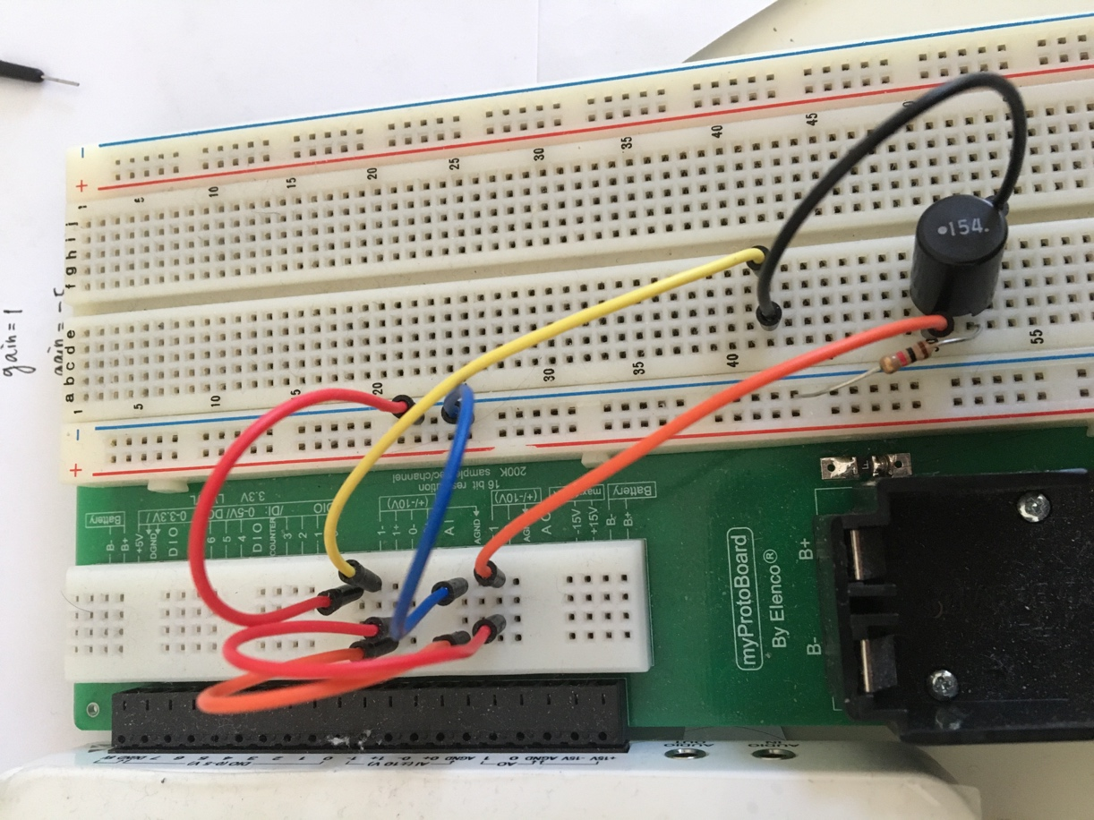

We connect the resistor and inductor as shown in the picture for part (a).

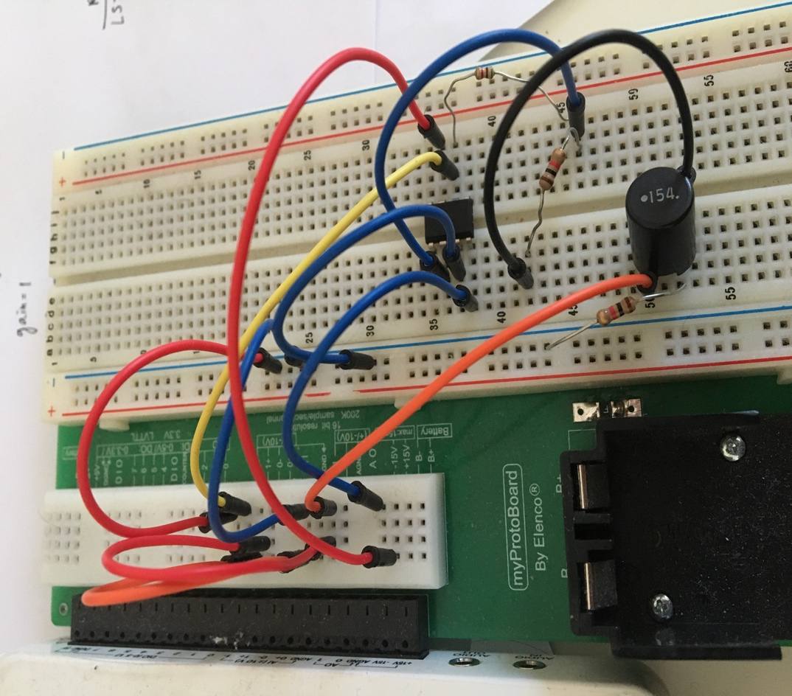

We connect the RL circuit, and direct the voltage across resistor to an inverting amplifier with transfer function of -5.

2.4 data and data analysis

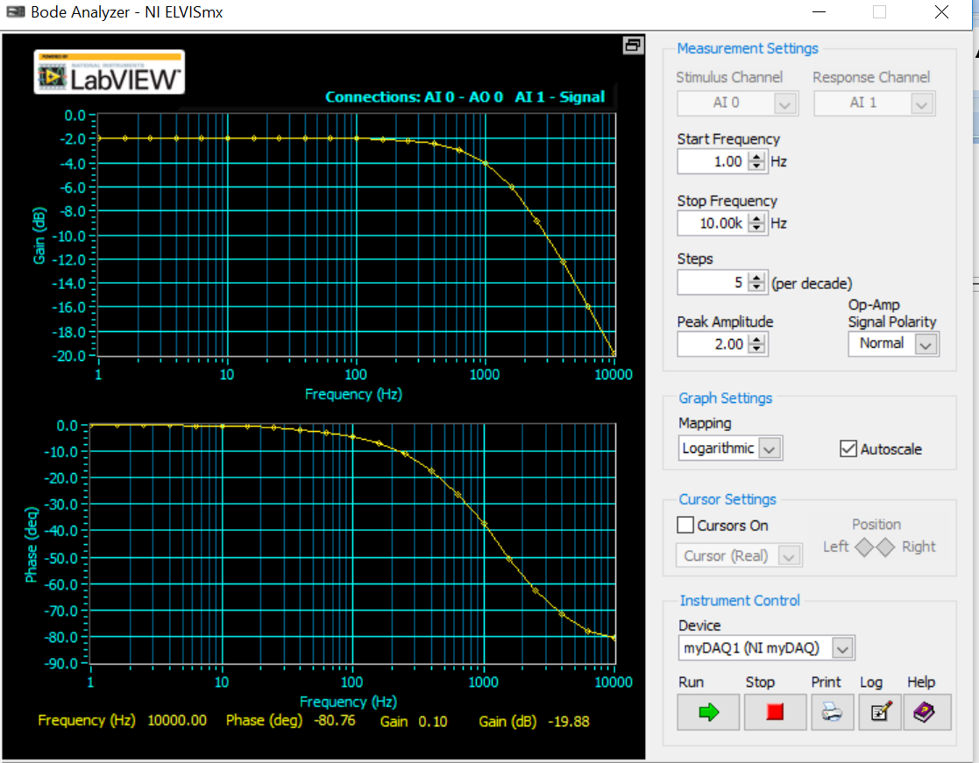

We get a RL circuit response for part (a). As frequency increases, the magnitude decreases. And from the phase plot we can observe the pole at -10^3.

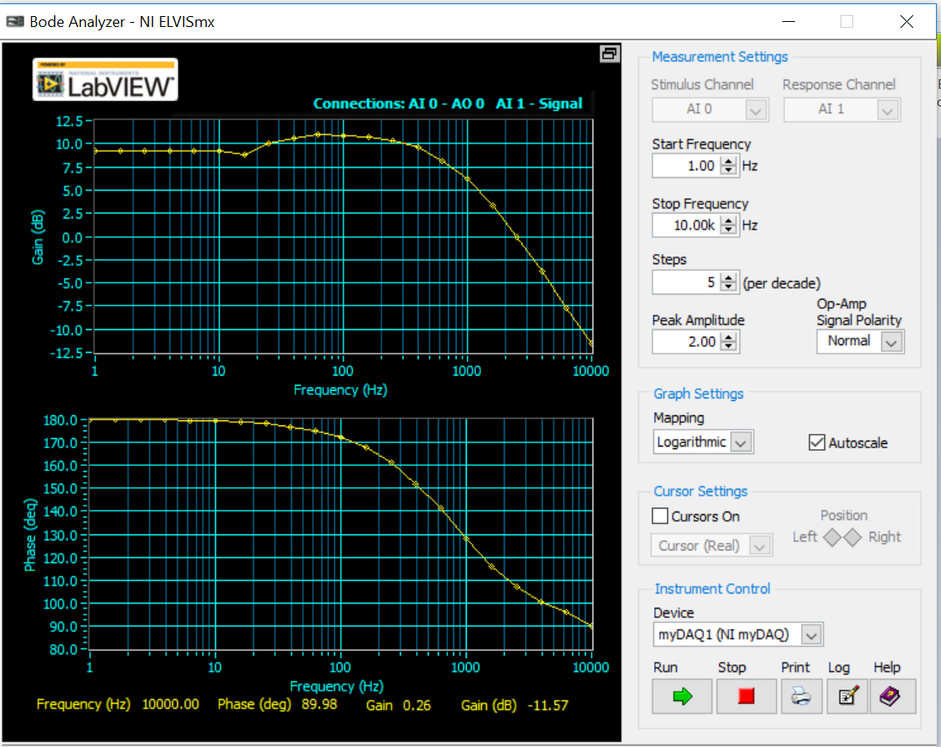

We have a RL circuit response that is multiplied with a factor of -5. The overall trend is still RL circuit response, and the magnitude decreases as frequency increases. From the phase plot we can observe the pole at 10^3.

2.5 error analysis

There are offsets in both of the bode plots, which is very likely caused by the internal resistance of the inductor. Also, the bode plot on myDaq can only start from 1 Hz instead of 0 Hz, which contributes a minimal error to the plots too. Last but not least, we used 1kOhms resistor to approximate the value of 942 Ohms, which would contribute error to magnitude when frequency is 1 Hz.

2.6 discussion

a. the transfer function for part a is derived in the theory section. For part b, we know the transfer function of inverting amplifier is – (R2/R1)\*input from lab 2. Thus the transfer function of part b is -5 / ( 1+ S/ (R/L)).

b. the time constant is R/L, theoretically, it would be 6.28\*10^3.

2.7 conclusion

We built 1st order circuit to achieve desired transfer functions by using resistor, inductor and opamp.

3.1 objective

Building 2nd-order circuits that have desired transfer functions with real poles.

3.2 Theory

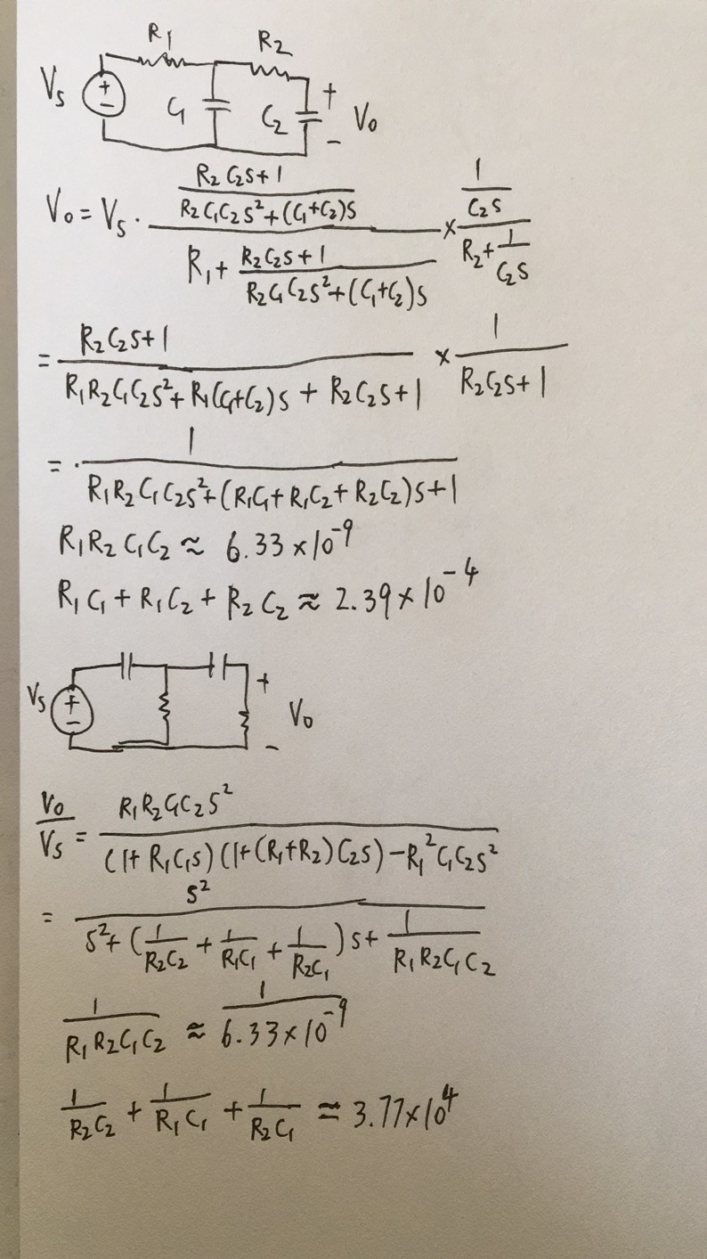

3.3 procedure

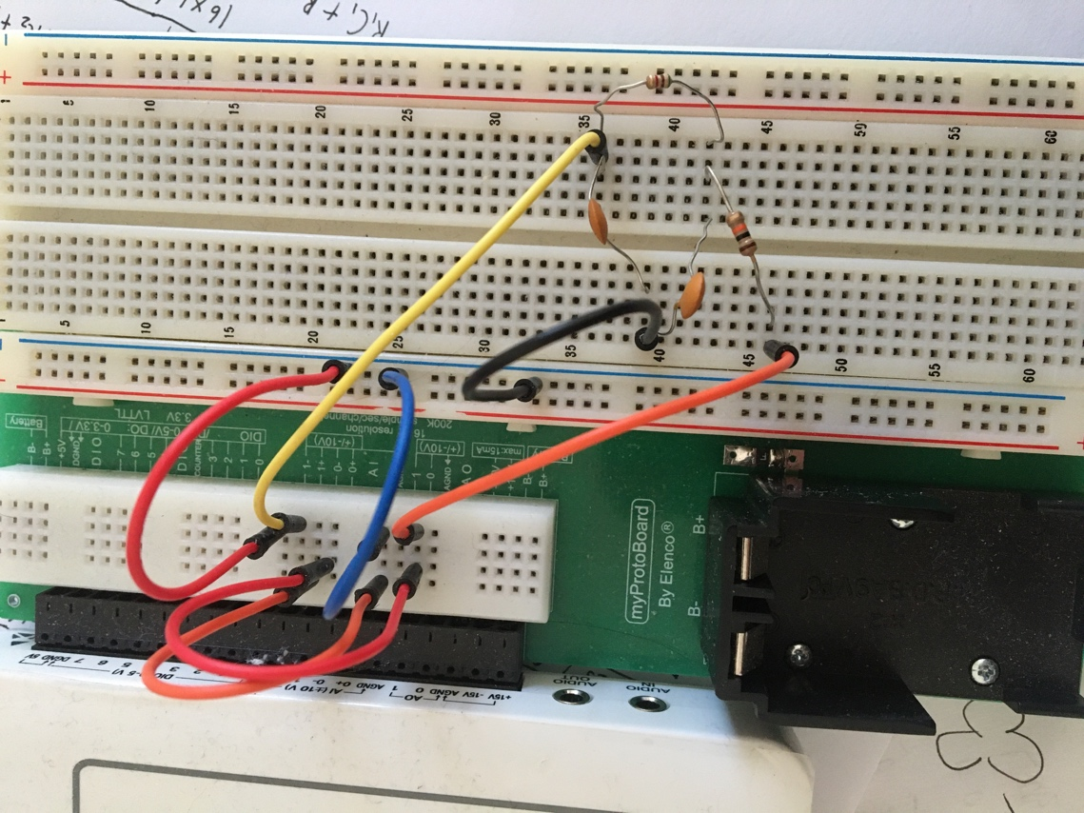

We connect two capacitors and two resistors as shown in the picture to produce a second order low pass filter.

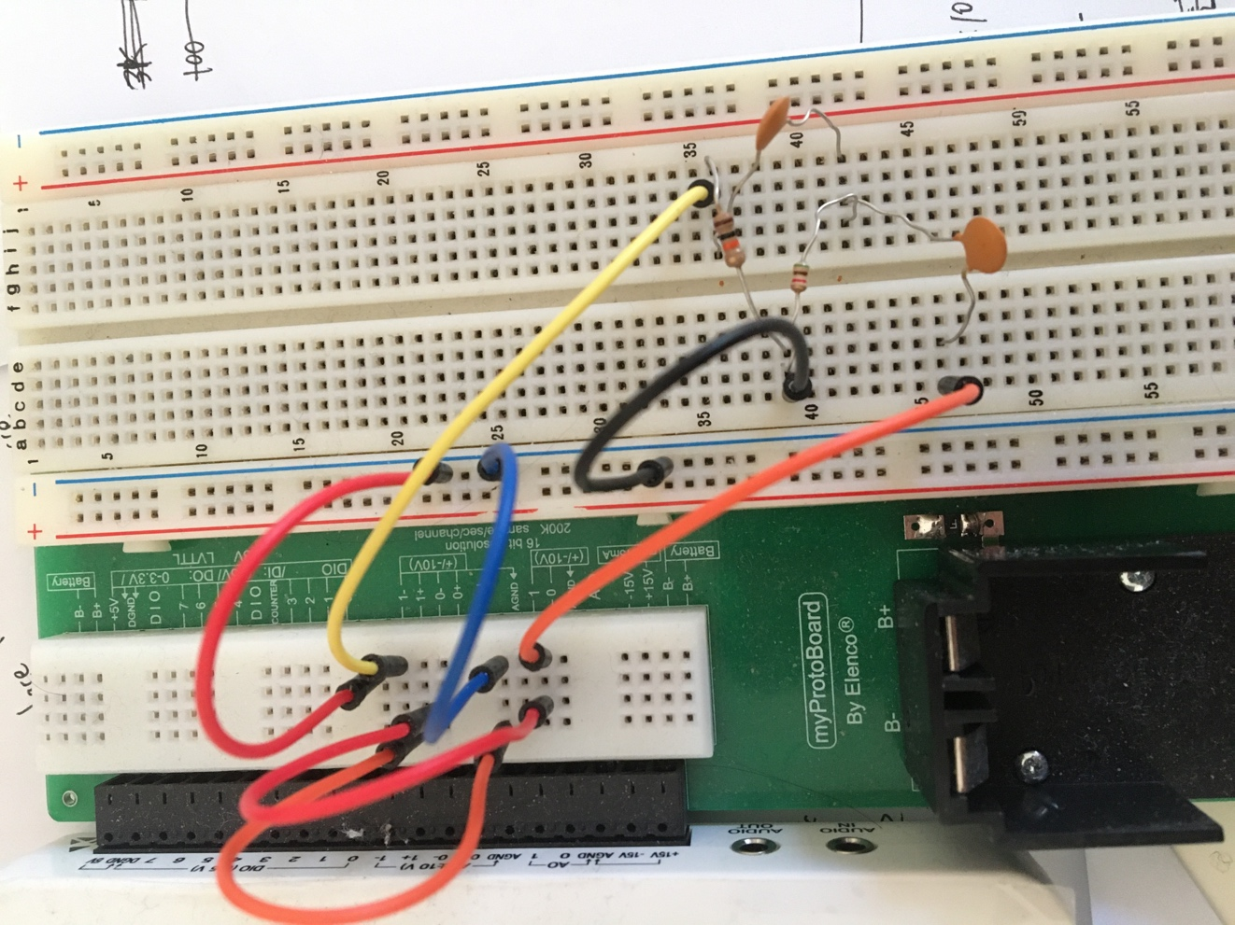

We connect two capacitors and two resistors as shown in the picture to produce a second order high pass filter.

3.4 data and data analysis

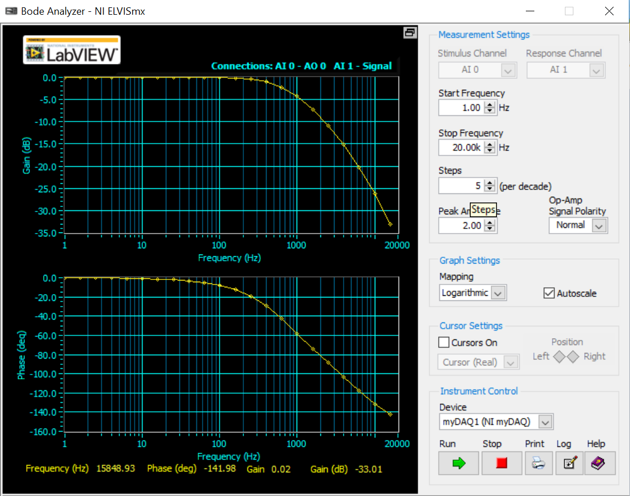

We get the response of a second order low pass filter. As frequency increases, magnitude decreases. At 0 frequency, the magnitude of bode plot is 0, which means we have a DC gain of 1.

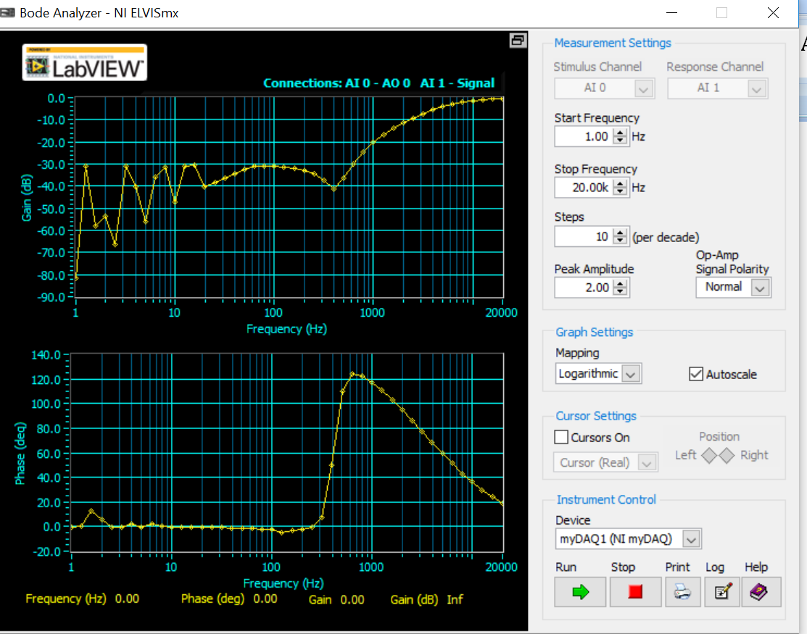

We get the response of a second order high pass filter. As frequency increases, magnitude increases. At large frequency, the magnitude of bode plot approaches 0, which means the value of our transfer function approaches 1 at large frequencies.

3.5 error analysis

For low pass filter, I used R1=10kOhms, R2= 5.1kOhms, C1=C2=10nF. This gives a value of 5.1\*10^(-9) to approximate the desired value of 6.33\*10^(-9) for R1\*R2\*C1\*C2. And the value will be 2.51\*10^(-4) to approximate 2.39\*10^(-4) for R1C1+R1C2+R2C2. For high pass filter, I used R1=5.1kOhms, R2= 10kOhms, C1=C2=10nF. This gives a value of 5.1\*10^(-9) to approximate the desired value of 6.33\*10^(-9) for R1\*R2\*C1\*C2. And the value will be 3.9\*10^4 to approximate 3.77\*10^4 for 1/R1C1+1/R2C1+1/R2C2.

3.6 discussion

a. the transfer functions are derived in the theory section.

b. Since the poles are real, the response is not damped.

c. the circuit for part (a) is low pass, and circuit for part(b) is high pass.

3.7 conclusion

We built 2nd-order low pass and high pass filters with capacitors and resistors to achieve desired transfer functions.

4.1 objective

Build 2nd-order RLC circuit to achieve desired transfer functions.

4.2 theory

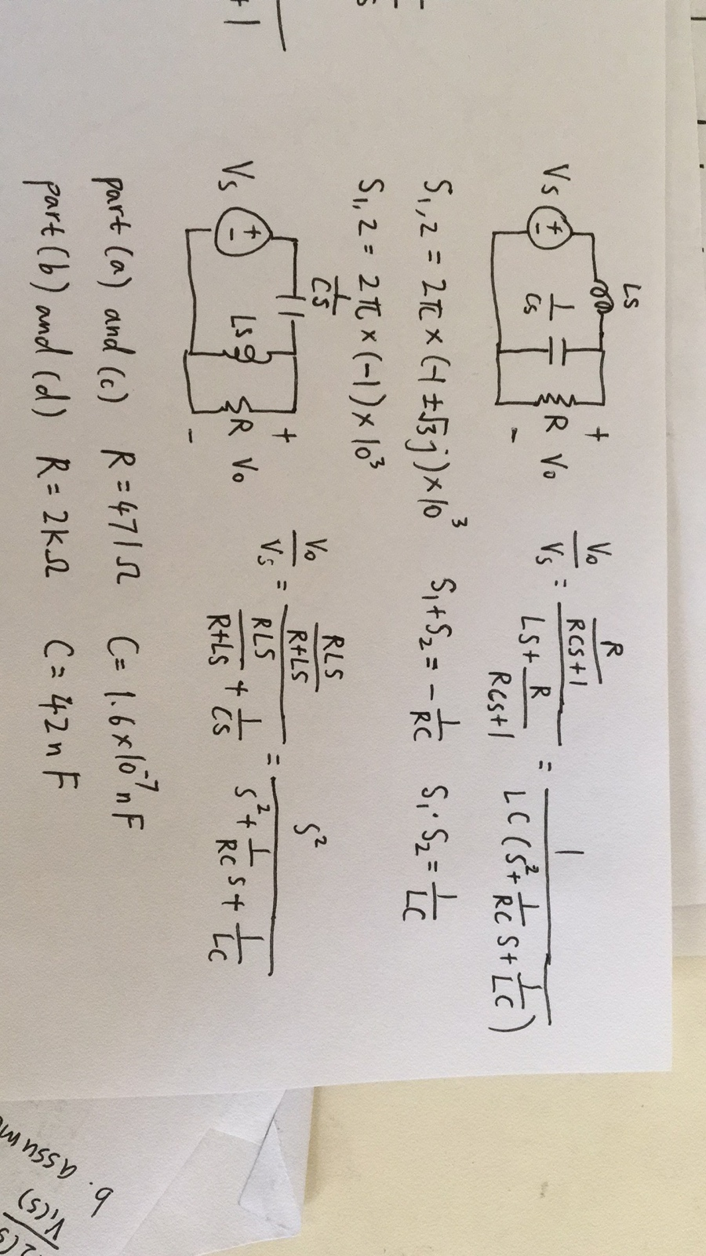

4.3 procedure

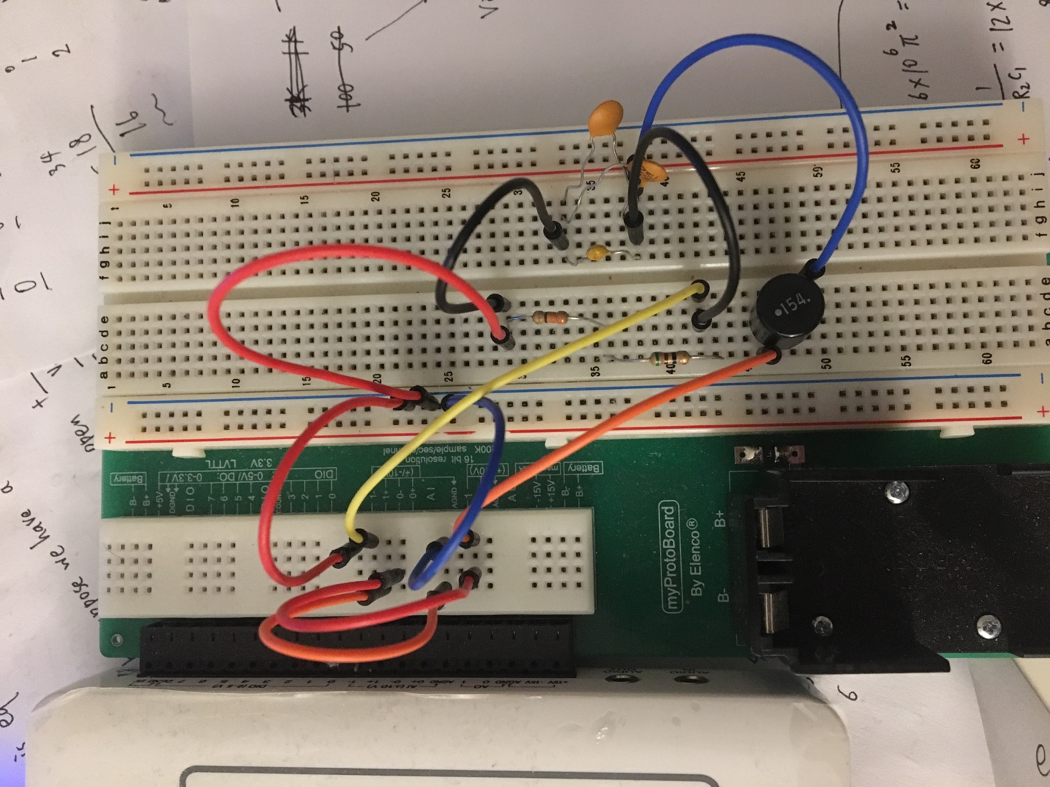

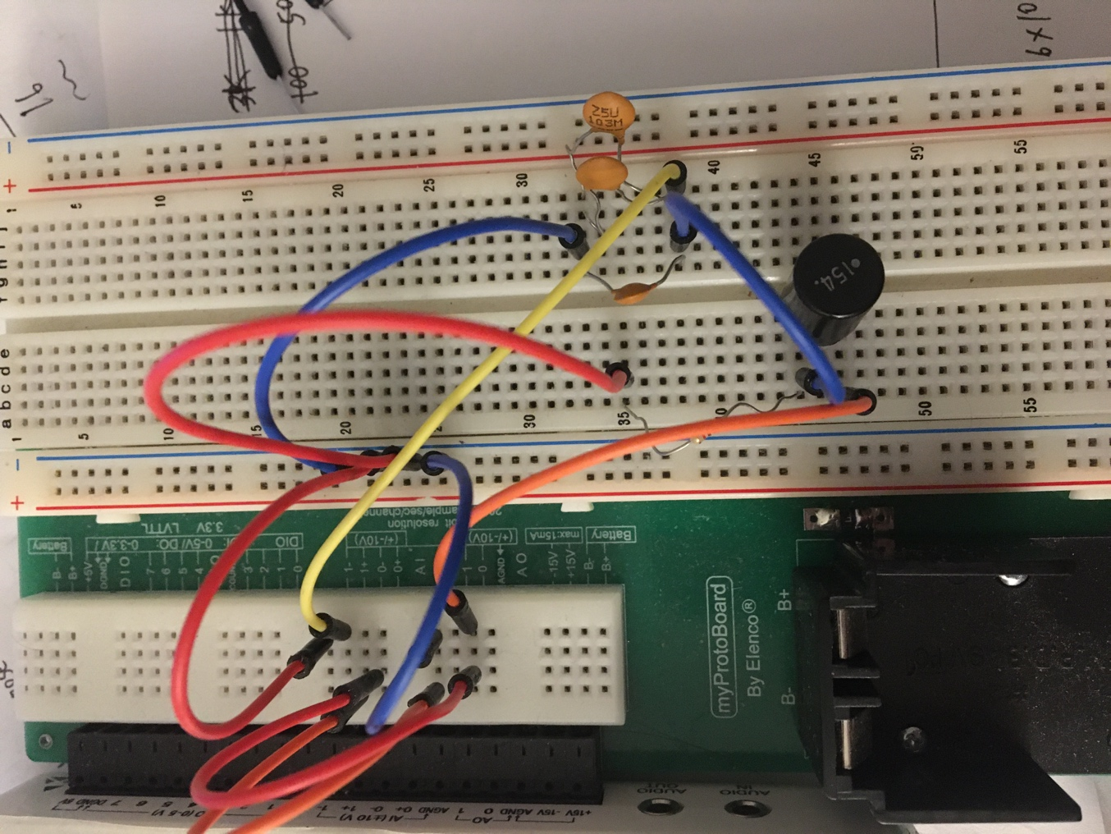

For low pass RLC circuits, we connect the components as shown in the above pictures. The input voltage goes through the inductor first, and then capacitors are in parallel with the resistor.

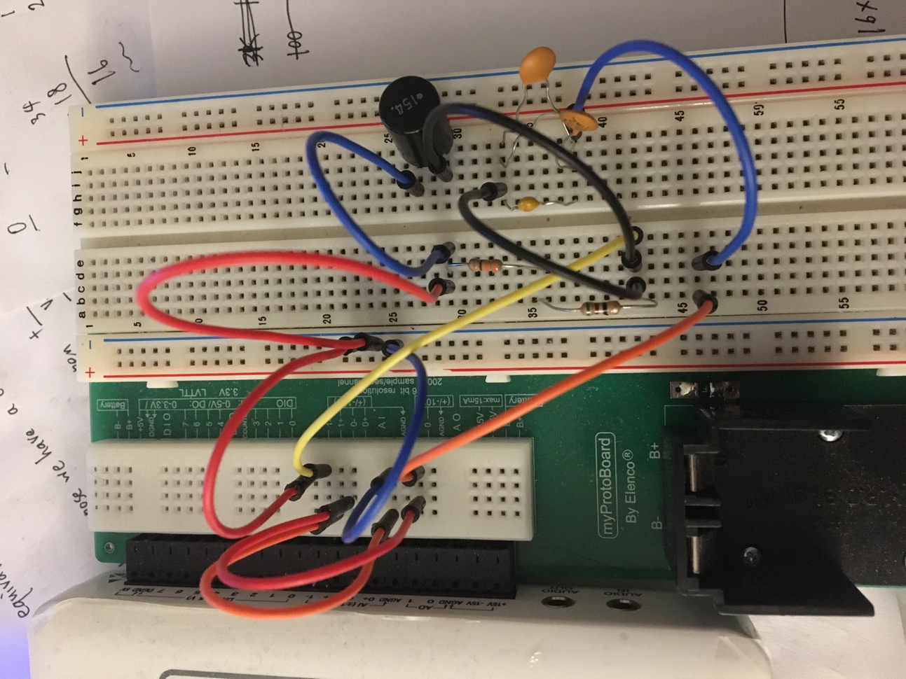

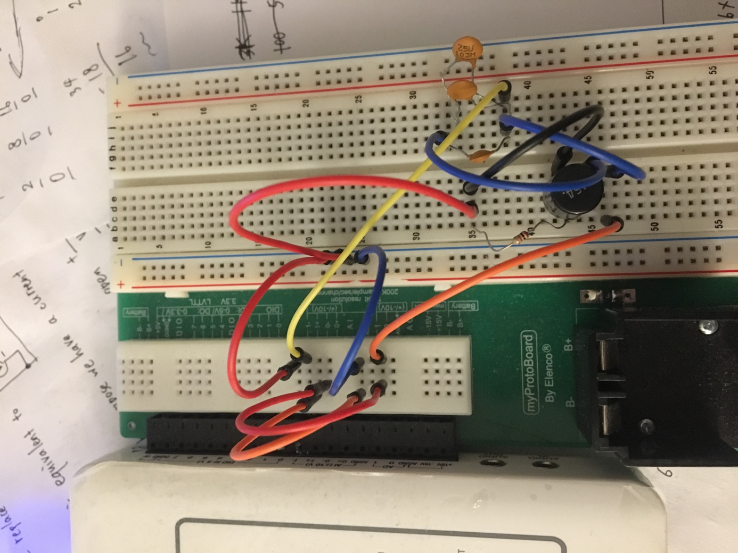

For high pass RLC circuits, we connect the components as shown in the above pictures. The input voltage goes through the capacitors first, and then indutors are in parallel with the resistor.

4.4 data and data analysis

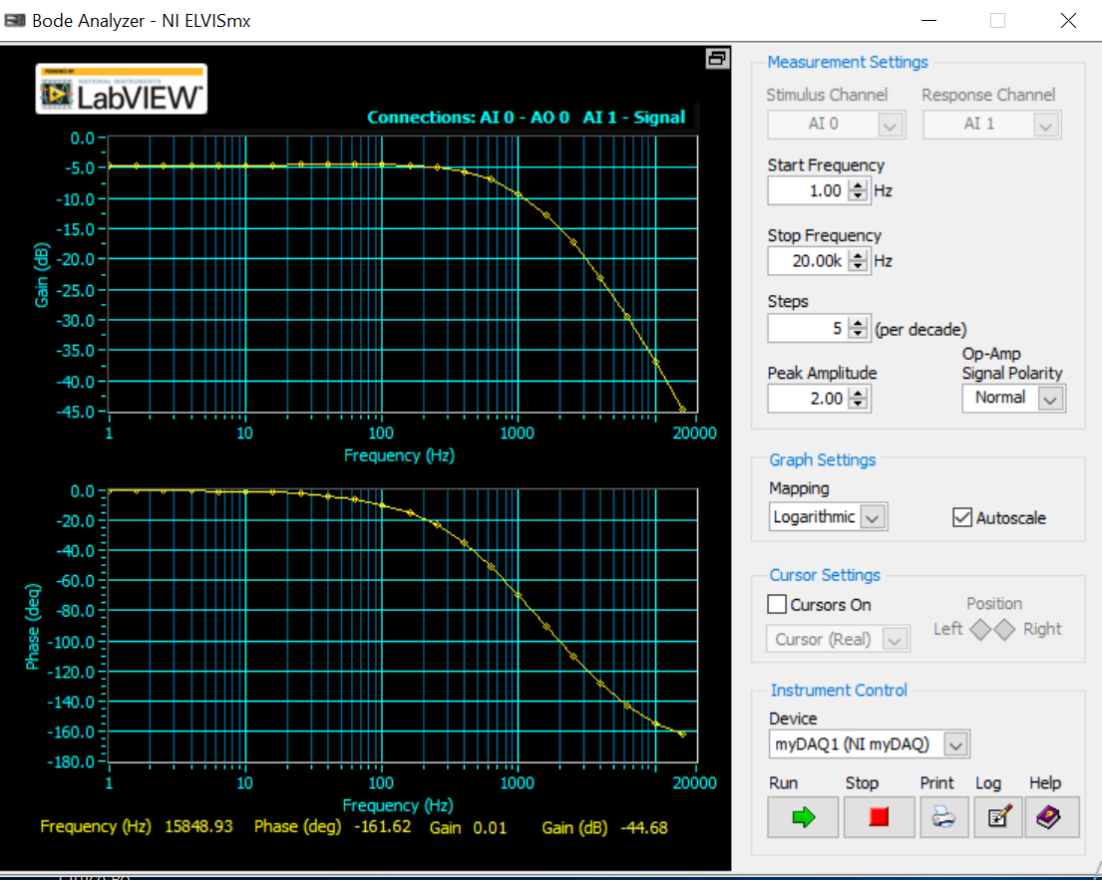

Part(a), response of 2nd-order RLC circuit with repeated poles. The plot has the characteristics of a low pass filter.

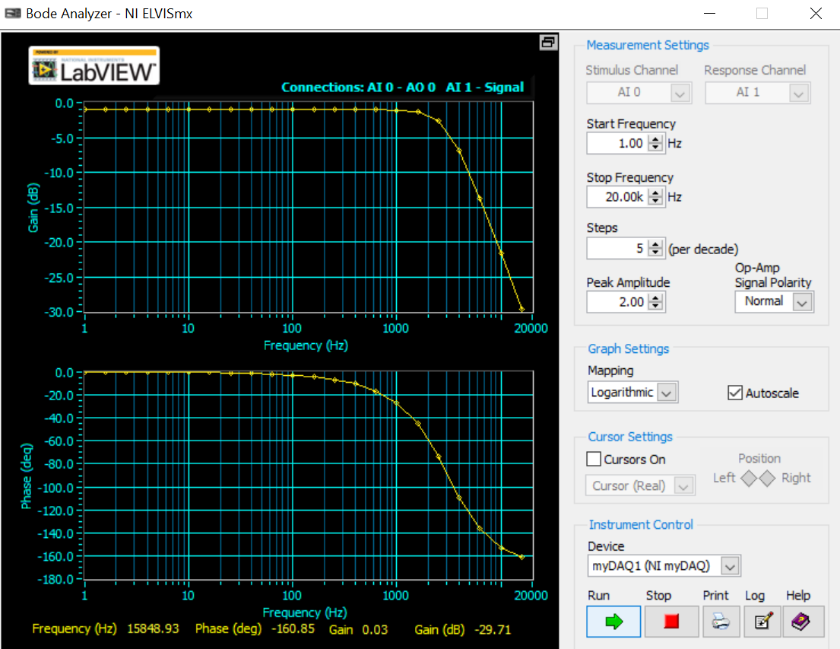

Part (b), response of 2nd-order RLC circuit with two complex poles. The plot has the characteristics of a low pass filter.

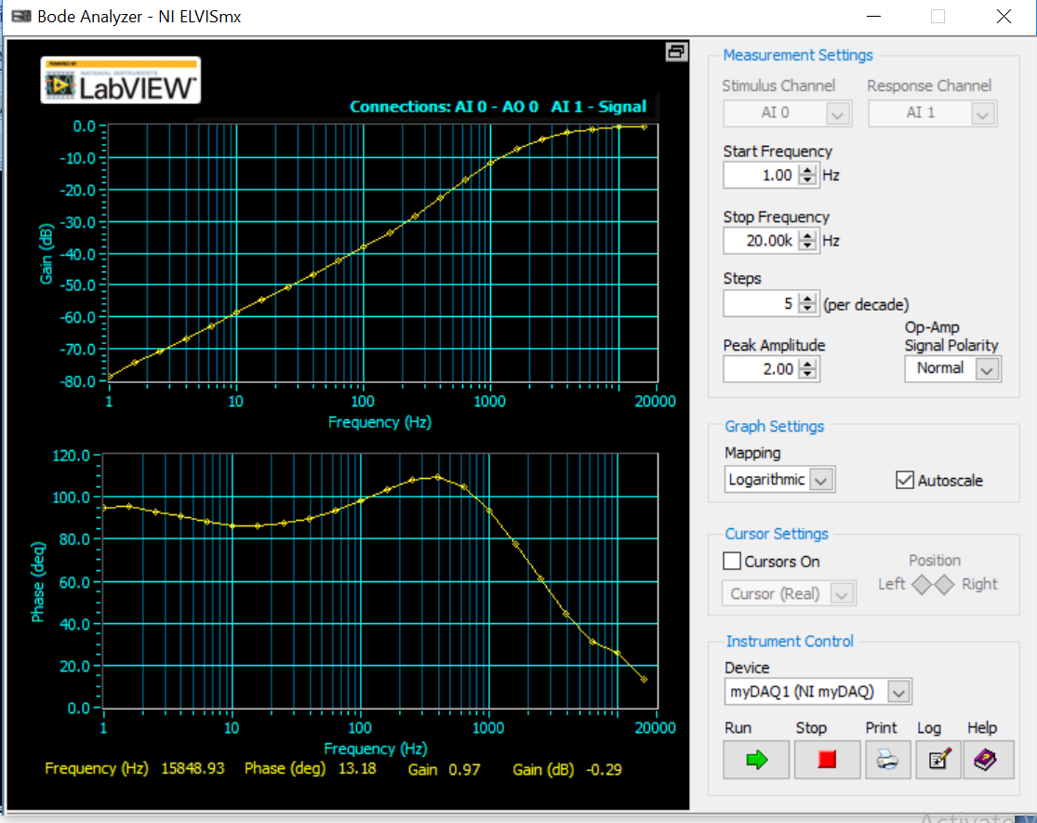

Part (c), response of 2nd-order RLC circuit with two repeated poles. The plot has the characteristics of a high pass filter.

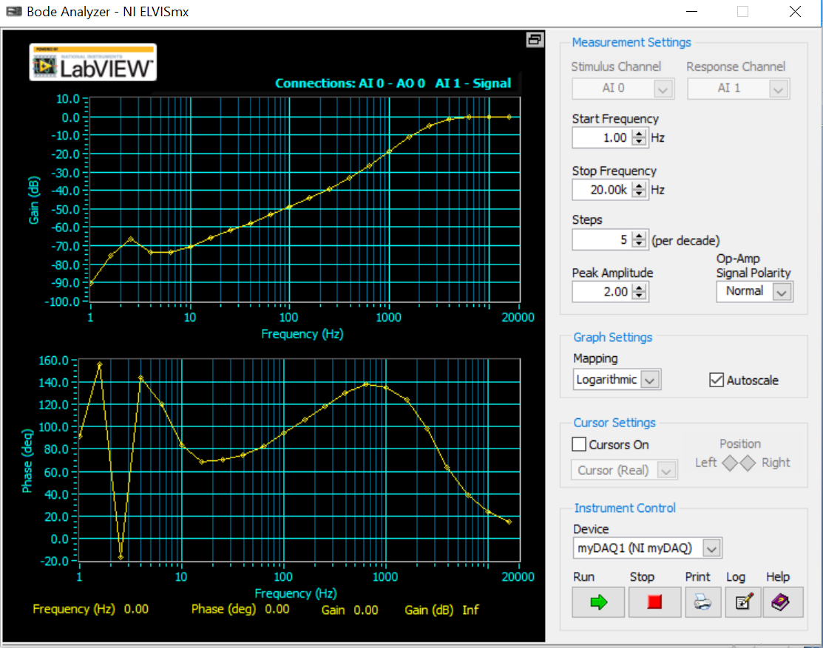

Part (d), response of 2nd-order RLC circuit with two complex poles. The plot has the characteristics of a high pass filter.

4.5 error analysis

For part a and c, I used 330 Ohms resistor and 50 Ohms resistor in series to create a value of 380 Ohms, to approximate the desired value of 470 Ohms. I used 100nF, 10nF and 10nF capacitors in parallel to create a capacitance of 120 nF, to approximate the desired value of 160 nF. For part b and part d, I used 22 nF, 10 nF and 10 nF capacitors in parallel to create a capacitance of 42 nF, and I used the 2 kOhms resistor. There are approximations in the values of components.

4.6 Discussion

a. the transfer functions are derived in the theory section.

b. the values of components are included in error analysis sections. The approximation of component values contributes to errors.

4.7 conclusion

We have built low pass and high pass RLC circuits to achieve desired transfer functions.